
MATHEMATICS DEPARTMENT
Year 11 Specialist – 2016
Test Number 1: Basic Vectors
Resource Free Section
Whole test:
/ 47 s
Weight:
2.5%

Name: ______SOLUTIONS___________________ Teacher: DDA
Marks: 31
Time Allowed: 30 minutes
Instructions: You ARE NOT permitted any notes or calculator. Show your working where appropriate remembering you must show working for questions worth more than 2 marks.
_________________________________________________________________________
1 Which of the following best describes the direction of the position vector of Q (–3, 7)?
A 113°
B –113°
C 203°
D 67°
E 337°
[1 mark]
2 Calculate the resultant of the forces shown below.
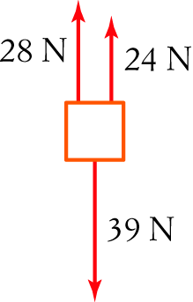
A 39 N down
B 91 N
C 52 N up
D 13 N up
E 13 N down
[1 mark]
3 This diagram shows vectors a, b and a third vector. Which of the following best describes the third vector?
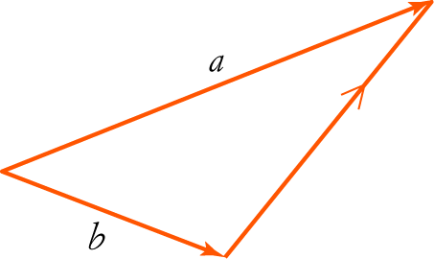
A a + b
B a + –b
C b + a
D b – a
[1 mark]
4 If m = i – 6j, which of the following vectors is opposite in direction to m?
A –6i + j
B (–2, –12)
– m = – i + 6j
Any multiple of this will be in the opposite direction to m
C (–2, 12)
D
E 6i – j

[1 mark]
5 This diagram shows vectors g and d. Which of the following best represents the resultant of g and d?
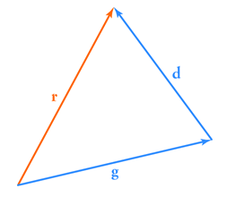
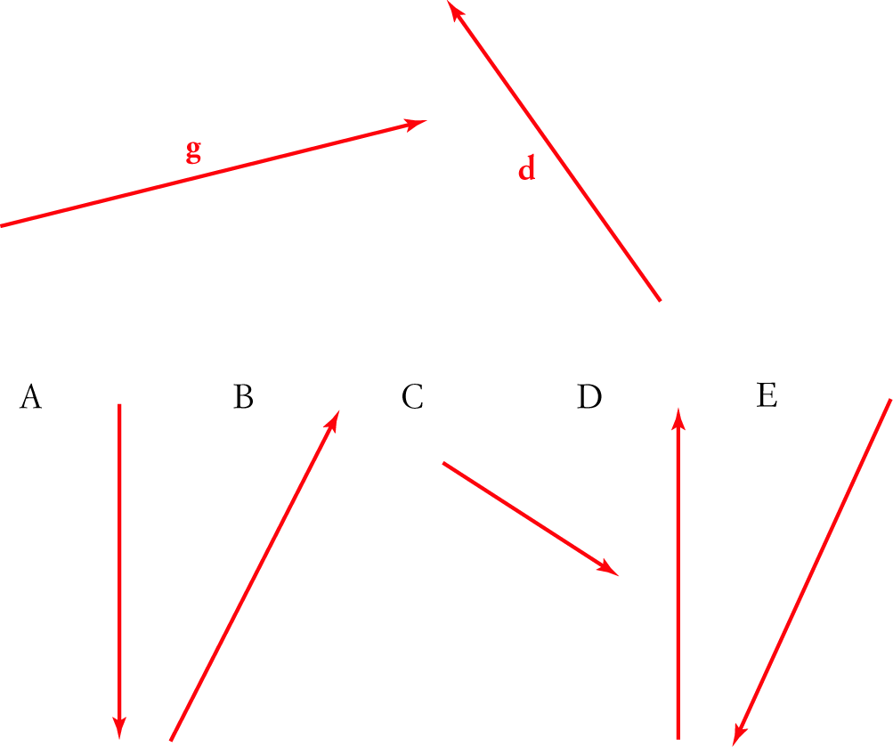

[1 mark]
6 Which of the following is orthogonal with (perpendicular to) n = (1, –1)?
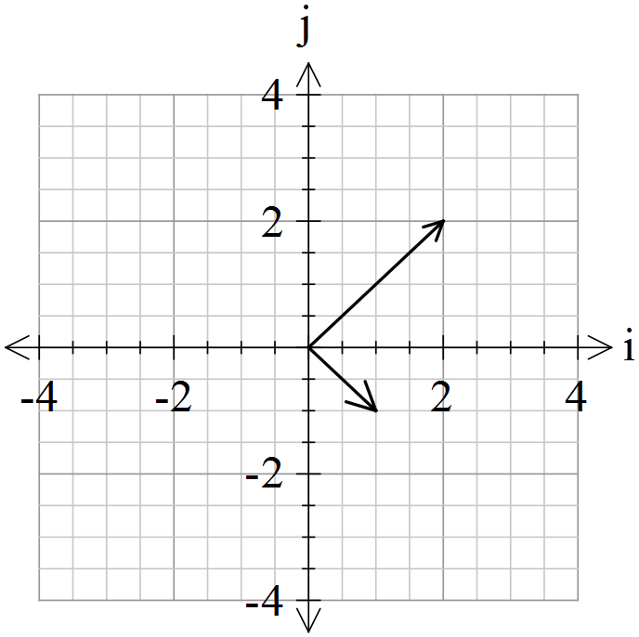A 2i + 2j
B (2, –1)
C –5i + 2j
D (–2, 2)
E (–4, 3)

[1 mark]
7 Write the following vectors in polar form.

a A vector a of magnitude 5 in the positive direction of the y-axis $\left(\begin{matrix}5 \\ 90°\end{matrix}\right)$

b A vector b with norm 7 in the negative direction of the x-axis $\left(\begin{matrix}7 \\ 180°\end{matrix}\right)$

c A vector c of magnitude 10 in a direction 135° anti-clockwise from the x-axis $\left(\begin{matrix}10 \\ 135°\end{matrix}\right)$

[3 marks]
8 Convert the vector to polar form. $\left(\begin{matrix}2\sqrt{2} \\ 45°\end{matrix}\right)$
[1 mark]
9 Find the norm of the vector (7, –24). 25
$$Pythagorean triple: 7, 24, 25$$

[1 mark]

10 Sketch each of the following vectors. (Clearly label all relevant parts of your sketch.)
a (–6, 9) b (3, 300°)
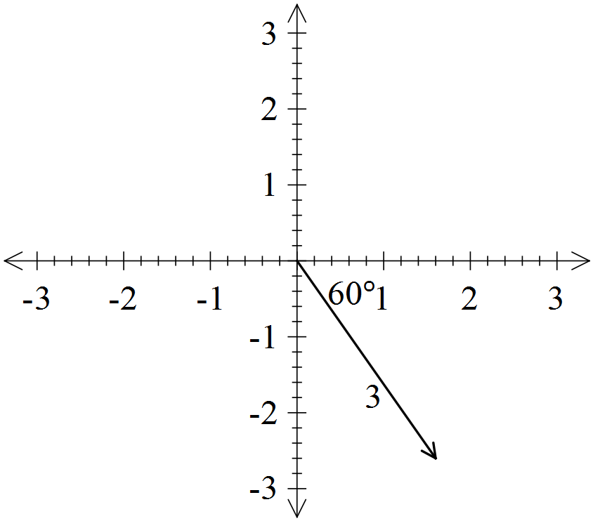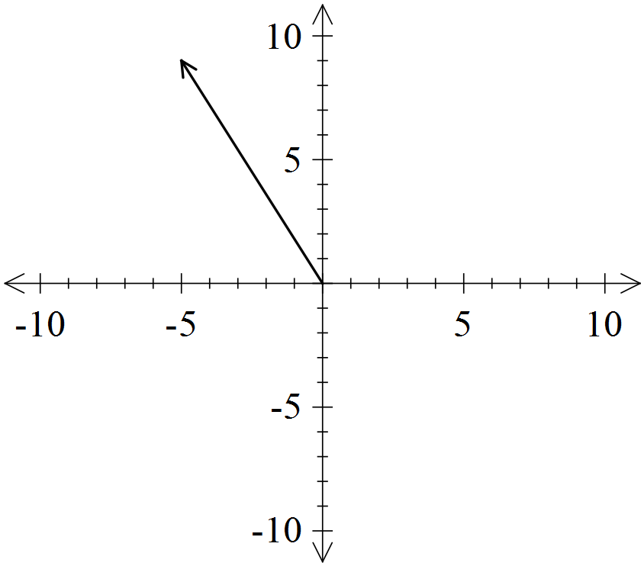

[2 marks]
11 Given b = (2, 7), d = (8, –2) and e = (–4, –2), find:

a 5e (–20, –10)

b 6d – 4b 6 (8, –2) – 4 (2, 7)
= (48, –12) – (8, 28)
= (40 , –40)

[2 marks]
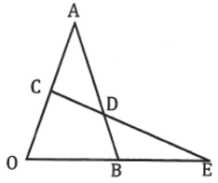
12 OAB is a triangle with C the mid-point of OA and D
a point of AB such that AD is two thirds of AB.
CD continued meets OB continued at E.

If $\vec{OA}=a$ and $\vec{OB}=b$ express each of the following in terms of $a$ and/or $b$. (Simplify your answers)
Must have tildes!!
-1 over Q 12 if they are missing
- $\vec{OC}$ $=\frac{1}{2}a$
- $\vec{AB}$ = $b-a$
- $\vec{AD}$ $=\frac{2}{3}(b-a)$
- $\vec{CD}$ $=\vec{CA}+\vec{AD}=\frac{1}{2}a+\frac{2}{3}\left(b-a\right)=\left(\frac{1}{2}-\frac{2}{3}\right)a+\frac{2}{3}b=-\frac{1}{6}a+\frac{2}{3}b$
- If $\vec{CE}=h\vec{CD}$ and $\vec{OE}=k\vec{OB}$ use the fact that $\vec{OC}+\vec{CE}=\vec{OE}$ to determine $h$ and $k$.

$$\vec{OC}+\vec{CE}=\vec{OE}$$
$$\vec{OC}+h\vec{CD}=k\vec{OB}$$

$\frac{1}{2}a+h\left(-\frac{1}{6}a+\frac{2}{3}b\right)=kb$
Equating coefficients of $a$: $\frac{1}{2}-\frac{h}{6}=0 ⟹ h=3$
Equating coefficients of $b$: $\frac{2h}{3}=k ⇒ k=2$

[8 marks]
13 Write as a linear combination of i and j. $4\tilde{i}-5\tilde{j}$ (Must have tilde)
[1 mark]
14 Find the displacement vector for the following movement.
Q(–2, –5) to P(–5, 4)
$$\vec{QP}=\vec{OP}-\vec{OQ}=\left(\begin{matrix}-5 \\ 4\end{matrix}\right)-\left(\begin{matrix}-2 \\ -5\end{matrix}\right)=\left(\begin{matrix}-3 \\ 9\end{matrix}\right)$$
[1 mark]
15 Using the component form of geometric vectors, complete the following proof for the associative law of vector addition.

Let $a=\left(\begin{matrix}x_{1} \\ y_{1}\end{matrix}\right), b= \left(\begin{matrix}x_{2} \\ y_{2}\end{matrix}\right) , c= \left(\begin{matrix}x_{3} \\ y_{3}\end{matrix}\right)$
RTP: $\left(a+b\right)+c=a+(b+c)$
Proof: LHS = $\left(a+b\right)+c$
= $\left(\begin{matrix}x_{1}+x_{2} \\ y_{1}+y_{2}\end{matrix}\right)+\left(\begin{matrix}x_{3} \\ y_{3}\end{matrix}\right)$
=$\left(\begin{matrix}x_{1}+x_{2}+x_{3} \\ y_{1}+y_{2}+y_{3}\end{matrix}\right)$
=$\left(\begin{matrix}x_{1} \\ y_{1}\end{matrix}\right)+ \left(\begin{matrix}x_{2}+x_{3} \\ y_{2}+y_{3}\end{matrix}\right)$
=$a+(b+c)$
= RHS

[3 marks]
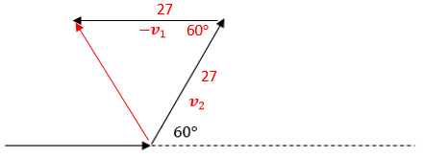
16 Without changing her speed, a speed skater travelling at 27 m/s changes direction by 60°. What is her change in velocity? $$∆v=v_{2}-v_{1}$$
Equilateral triangle
$∴change in velocity is 27$m/s in direction $120°$

[3 marks]


MATHEMATICS DEPARTMENT
Year 11 Specialist – 2016
Test Number 1: Basic Vectors
Resource Rich Section
Name: _______________________________________ Teacher: __________________
Marks: 16
Time Allowed: 15 minutes
Instructions: You ARE allowed 1 page of notes (both sides) and a CAS calculator.
You must show your working to receive full marks whenever a question is worth more than 2 marks. Where relevant, and unless otherwise, specified give answers to 2 decimal places.
_________________________________________________________________________
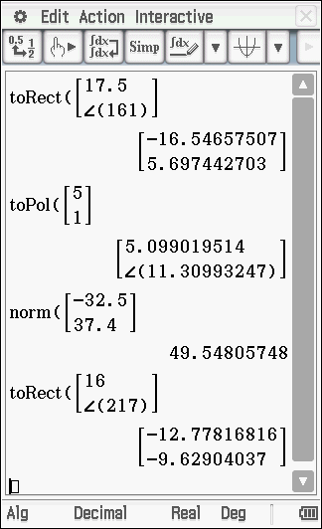
17 Convert the vector (17.5, 161°) to component form.
$$\left[\begin{matrix}-16.55 \\ 5.70\end{matrix}\right]$$
[1 mark]
18 Convert the vector (5,1) to polar form.

$\left[\begin{matrix}5.10 \\ 11.31°\end{matrix}\right]$
[1 mark]
19 Find the norm of the vector .
49.55

1 mark]
20 Write (16, 217°) as a linear combination of i and j.

$-12.78i-9.63j$

[1 mark]
21 Given y = (22, 342°) and z = (15, 72°) , find y + z without changing to component form.

$$θ$$
18$°$
15
$$90°$$
18$°$
72$°$
22

$\left|y+z\right|=\sqrt{{22}^{2}+{15}^{2}}=26.62705391…$
$θ=\tan^{-1}\left(\frac{15}{22}\right)=34.28687698…$
$∴y+z=\left(\begin{matrix}26.63 \\ 16.29°\end{matrix}\right)$
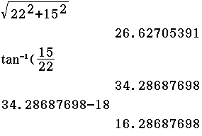

[4 marks]
22 Given g = (18, 144°) and m = (30, 225°), find g – m. Give your answer in polar form.
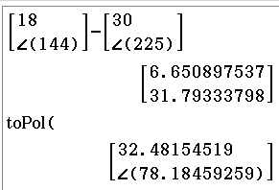
$g-m=\left(\begin{matrix}32.48 \\ 78.18°\end{matrix}\right)$

[2 marks]

23 A boat travels 19 nautical miles in a direction N 30° E and then travels 25 nautical miles south-east.
Express each of these displacements in component form (east and north) and hence find the displacement for the whole journey in polar form. (Give positive polar angle.)

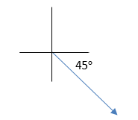
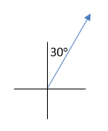

$v_{1}=\left(\begin{matrix}19 \\ 60°\end{matrix}\right)$ $v_{2}=\left(\begin{matrix}25 \\ -45°\end{matrix}\right)$
$v_{1}=\left(\begin{matrix}9.5 \\ 16.45\end{matrix}\right)$ $v_{2}=\left(\begin{matrix}17.68 \\ -17.68\end{matrix}\right)$
$v_{1}+v_{2}=\left(\begin{matrix}27.21 \\ -2.58°\end{matrix}\right)=\left(\begin{matrix}27.21 \\ 357.42°\end{matrix}\right)$
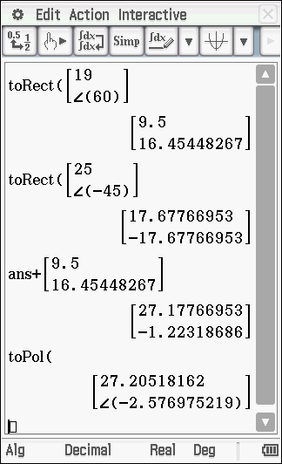

[6 marks]

